 | FirstName LastName  Undergraduate Student,  Bangladesh University of Engineering and Technology |  |  | 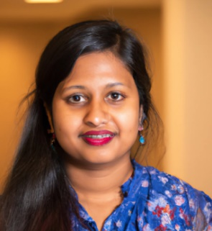
Present Address  317 Kazi Nazrul Islam Hall  BUET, Dhaka 1000  Mobile: +88 01711 978855  Email: sajid@eee.buet.ac.bd  WhatsApp: +17654009040  LinkedIn: /in/hashraful  ORCID: 0000-0003-2765-2589 |  | Profile  Write a 30-40 word intro about yourself and your future goals.
Permanent Address  4567 Main Street  Brooklyn, New York 48127  (718) 555 – 0100  Emergency Contact: FName Last N (Relationship) Mobile No |  | Education  BSc Engg (EEE), Bangladesh University of Engineering and Technology (BUET), Expected Year of Graduation [Graduation Year], Current CGPA: [Current CGPA]  HSC, [Name of College], [Passing Year], [GPA]  SSC, [Name of School], [Passing Year], [GPA]
Key Skills  PSpice, PCB Design, Matlab, Python, Cadence Virtuoso  Activities and Interests  [List any extracurricular activities or club memberships you have participated in, e.g. Robotics Club, Debate Club, etc.]  Member, IEEE BUET Student Br  Member, BUET Drama Society  Contact QR Code  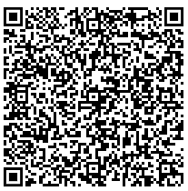 |  | Project Work:  [List your major project works here, e.g. a project on "Design and Implementation of a Smart Home Automation System", which involved developing a mobile app, using Arduino and Raspberry Pi]  Publications:  [List any publications or research papers you have authored or co-authored here, if any. Write None if you don’t have any]  Scholarships and Awards  [List any academic scholarships or awards you have received, e.g. BUET Merit Scholarship, National Science and Technology (NST) Scholarship, etc.]  References  [List of references. Your first reference should be your academic advisor]  All text should be black. Remove blue texts.  <- generate a QR code for your contact using https://www.qr-code-generator.com/ use vcard type QR code

